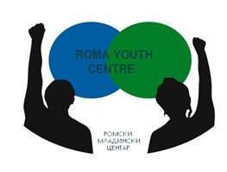

Application Form

for participation in the international Training Course:

“Building Roma Youth Leaders through Active Youth Work”
19-26 April 2013 – Macedonia

Participant’s details:

Name and Surname:
Country:
Age:
Gender:
Address:
e-mail:
Mobile Phone:

Organization’s Details:
(If you are applying as individual do not fill this field)

Name of organization / institution:
Type of organization (NGO, public body…)
Country:
Address:
e-mail:
Phone/fax:
Web:

Please answer the following questions:

(If you are applying as individual do not fill this field)

What is your role in your organization/institution (employed youth worker, volunteer, project coordinator…)

What is your experience in working with Roma young people?

How can you contribute for this activity as a participant?

Why do you want to participate in this project?

Do you have any special needs?

How much cost the cheapest kind of transport from your town to Skopje and back?

Please send the filled application form to info_romayouthcentre@yahoo.com by the:
05th of April 2013

Good Luck☺ !

